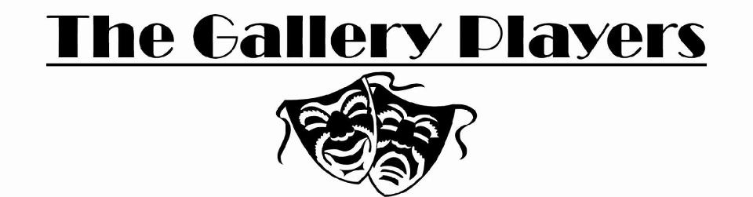
Production Expectations
Anyone participating in a Gallery Players production in any capacity is a member of the organization.
As a member of Gallery Players, I pledge to uphold the high standards established since it was founded in 1972. I understand that a production is the sum of its many parts. That is: EACH AND EVERY ROLE IS VITAL TO THE SHOW.
Technicians are as important as actors. These are the people who stage manage, work with lighting, sound, set design and construction, wardrobe, props, and publicity – in short, anyone who helps in any way to support the efforts of the actors and directors to make the show happen.
Not taking responsibilities seriously show disrespect for everyone involved in the show.
Therefore, knowing that the success of an all-volunteer organization is dependent on everyone doing their fair share, I promise that:
1. Except for conflicts noted on my audition sheet, I will be available and on time for all rehearsals and all scheduled performances, except in the event of an unforeseeable and URGENT conflict (or my designated substitute identified in advance to the producer) will be available to help with load-in prior to the show and with strike after the show. I will actively assist in every way possible to ensure the success of the show.
2. If cast in a musical, I will give the producers a $25.00 check as a deposit on my script. This amount is the replacement price if the book is lost or damaged. The check will be returned to me when my script book is returned at the close of the show provided it is in good condition.
3. I will assist in obtaining props and costumes.
4. I will work on set construction at least once.
5. I will be responsible for all props and costumes borrowed by me or issued for my use in the production and will ensure that they are returned and are in good repair following the production. I understand the costumes are the sole property of The Gallery Players
6. I understand that the directors are the ultimate decision-makers with the regard to the artistic form of the production and I agree to make every effort to follow direction.
7. I understand that Gallery Players must provide consistently high quality shows to ALL of its patrons. I therefore agree that I will not engage in any prank or joke during any production which changes or takes the risk of changing the performance or set as seen by the audience.
8. By accepting a role, I understand my obligations. Should circumstances arise that prevent me from fulfilling these obligations, I understand I will be given an opportunity to work in another capacity on the show. If this is not possible, this information and the reasons for this situation will be shared with the directors of the next 4 shows for which I audition.
I agree with and accept the conditions listed above.
_____________________________________________________
Actor’s Signature
_____________________________________________________
Parent or Guardian’s signature if actor is under 18 years of age
_____________________________________________________ ________________________________
Producer’s Signature Title of show

